Task Description #1 – Syntax and Logic Errors
Task: Use AI to identify and fix syntax and logic errors in a faulty
Python script.
Sample Input Code:
# Calculate average score of a student
def calc_average(marks):
total = 0
for m in marks:
total += m
average = total / len(marks)
return avrage # Typo here
marks = [85, 90, 78, 92]
print(&quot;Average Score is &quot;, calc_average(marks)
Expected Output:
• Corrected and runnable Python code with explanations of the
fixes.
PROMPT: :- Fix the errors in this Python code. Give the corrected code, explain the fixes briefly, and show the output.

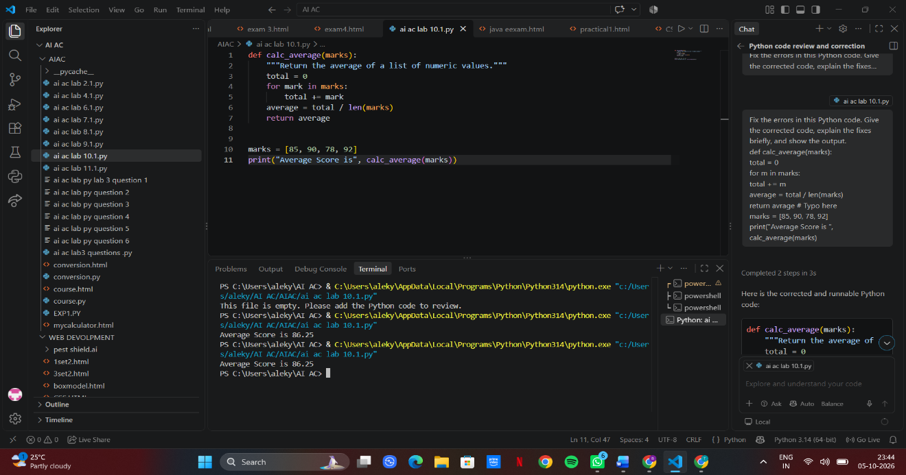
Task Description #2 – PEP 8 Compliance
Task: Use AI to refactor Python code to follow PEP 8 style
guidelines.
Sample Input Code:
def area_of_rect(L,B) : return L*B
print(area_of_rect(10,20))
Expected Output:
• Well-formatted PEP 8-compliant Python code.
PROMPT: Refactor the following Python code according to PEP 8 guidelines. Fix formatting, spacing, indentation, and variable naming while keeping the functionality unchanged. Explain the changes briefly.

def area_of_rect(L,B) : return L*B
print(area_of_rect(10,20))
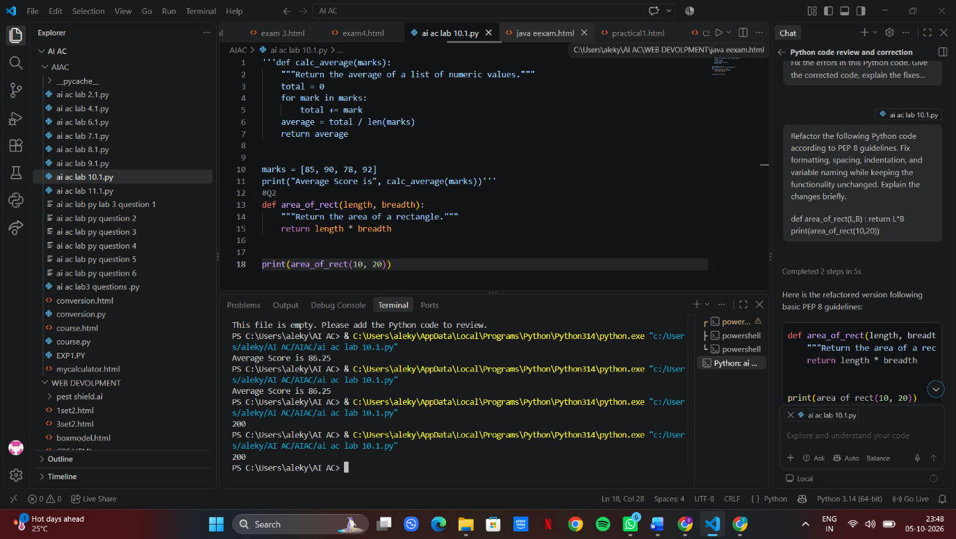
Task Description #3 – Readability Enhancement
Task: Use AI to make code more readable without changing its
logic.
Sample Input Code:
def c(x,y):
return x*y/100
a=200
b=15
print(c(a,b))
Expected Output:
• Python code with descriptive variable names, inline

comments, and clear formatting.
PROMPT: Make the following Python code more readable without changing its logic. Use descriptive variable and function names, add inline comments, and apply clear formatting.
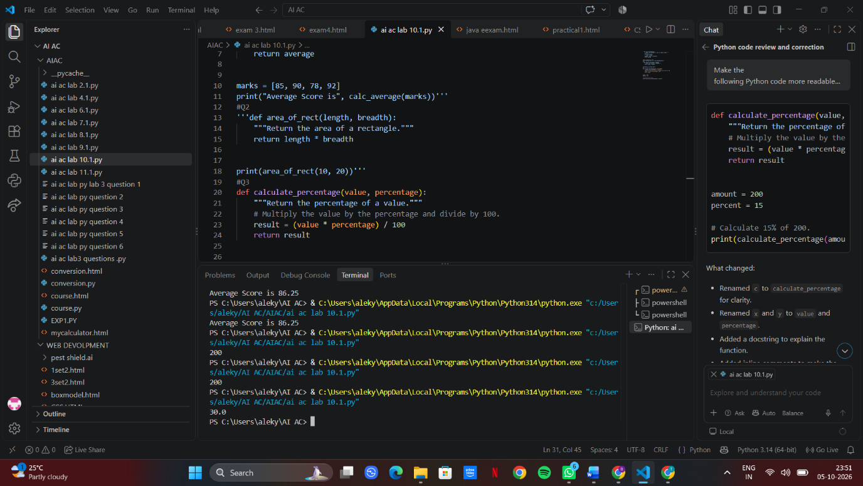
Task Description #4 – Refactoring for Maintainability
Task: Use AI to break repetitive or long code into reusable
functions.
Sample Input Code:
students = [&quot;Alice&quot;, &quot;Bob&quot;, &quot;Charlie&quot;]
print(&quot;Welcome&quot;, students[0])
print(&quot;Welcome&quot;, students[1])
print(&quot;Welcome&quot;, students[2])
Expected Output:
• Modular code with reusable functions.
PROMPT: Refactor the following Python code for better maintainability. Create a reusable function to eliminate repetition, keep the logic unchanged, and provide clear, well-formatted code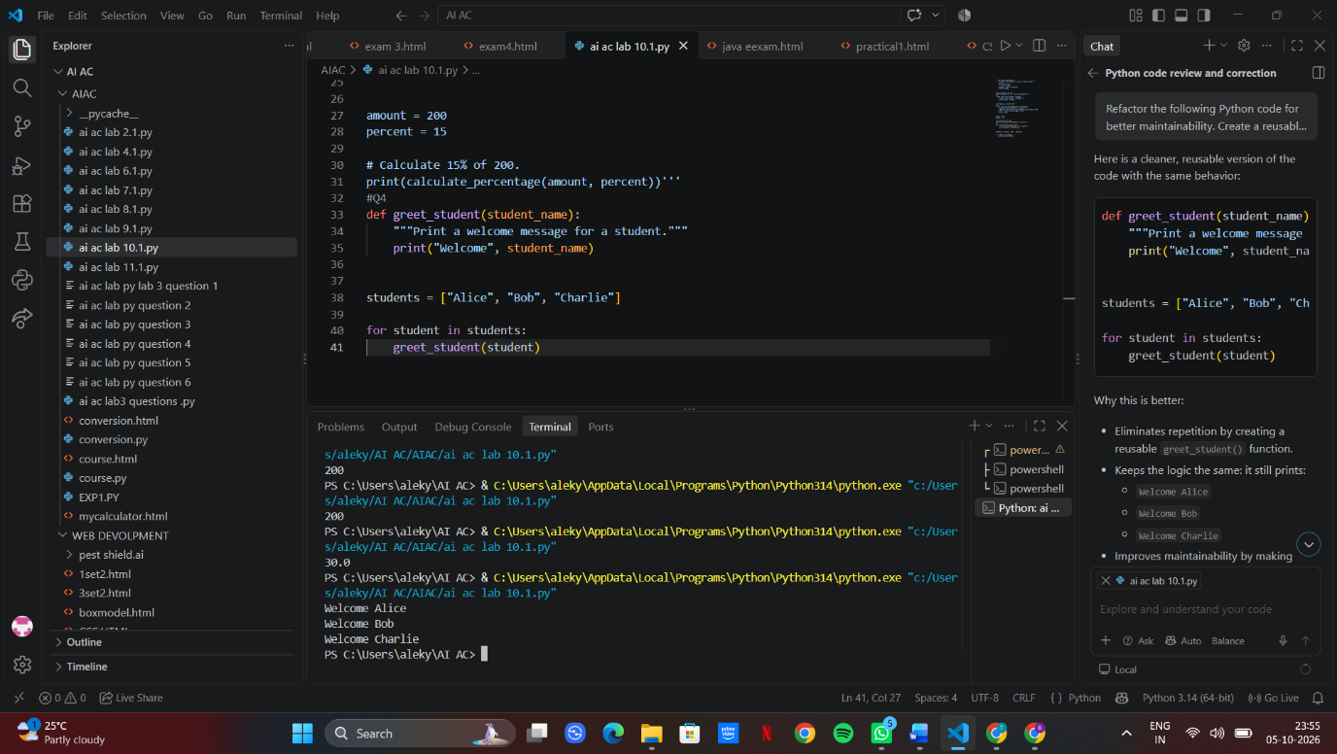
Task Description #5 – Performance Optimization
Task: Use AI to make the code run faster.
Sample Input Code:
# Find squares of numbers
nums = [i for i in range(1,1000000)]
squares = []

for n in nums:
squares.append(n**2)
print(len(squares))
Expected Output:
• Optimized code using list comprehensions or vectorized
operations.
PROMPT: Optimize the following Python code for better performance. Use a list comprehension or other efficient approach, keep the logic and output unchanged, and explain the optimization briefly.

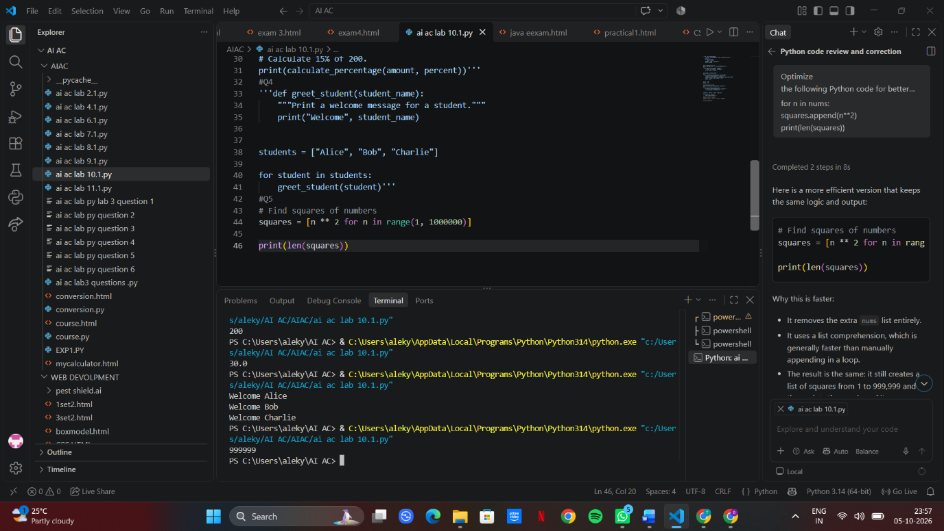
Task Description #6 – Complexity Reduction
Task: Use AI to simplify overly complex logic.
Sample Input Code:
def grade(score):
if score &gt;= 90:
return &quot;A&quot;
else:
if score &gt;= 80:
return &quot;B&quot;
else:
if score &gt;= 70:
return &quot;C&quot;
else:
if score &gt;= 60:
return &quot;D&quot;
else:
return &quot;F&quot;
Expected Output:
• Cleaner logic using elif or dictionary mapping.
PROMPT: Simplify the following Python code to reduce its complexity. Use elif or another clean approach, keep the logic unchanged, and provide clear, readable code.


